**Attrition Analysis**

**Step 1: Launching**

import pandas as pd

dataset = pd.read_excel("Attrition Analysis Data.xlsx", sheet_name = 0)

dataset.head()

Out[3]:

Age Attrition ... YearsSinceLastPromotion YearsWithCurrManager

0 51 No ... 0 0

1 31 Yes ... 1 4

2 32 No ... 0 3

3 38 No ... 7 5

4 32 No ... 0 4

[5 rows x 24 columns]

dataset.tail()

Out[4]:

Age Attrition ... YearsSinceLastPromotion YearsWithCurrManager

4405 42 No ... 0 2

4406 29 No ... 0 2

4407 25 No ... 1 2

4408 42 No ... 7 8

4409 40 No ... 3 9

[5 rows x 24 columns]

dataset.columns

Out[5]:

Index(['Age', 'Attrition', 'BusinessTravel', 'Department', 'DistanceFromHome',

'Education', 'EducationField', 'EmployeeCount', 'EmployeeID', 'Gender',

'JobLevel', 'JobRole', 'MaritalStatus', 'MonthlyIncome',

'NumCompaniesWorked', 'Over18', 'PercentSalaryHike', 'StandardHours',

'StockOptionLevel', 'TotalWorkingYears', 'TrainingTimesLastYear',

'YearsAtCompany', 'YearsSinceLastPromotion', 'YearsWithCurrManager'],

dtype='object')

**Step 2: Data Treatment**

dataset.duplicated()

Out[6]:

0 False

1 False

2 False

3 False

4 False

4405 False

4406 False

4407 False

4408 False

4409 False

Length: 4410, dtype: bool

dataset1 = dataset.drop_duplicates()

dataset1.isnull()

Out[8]:

Age Attrition ... YearsSinceLastPromotion YearsWithCurrManager

0 False False ... False False

1 False False ... False False

2 False False ... False False

3 False False ... False False

4 False False ... False False

... ... ... ... ...

4405 False False ... False False

4406 False False ... False False

4407 False False ... False False

4408 False False ... False False

4409 False False ... False False

[4410 rows x 24 columns]

working_dataset = dataset1.dropna()

working_dataset.info()

<class 'pandas.core.frame.DataFrame'>

Int64Index: 4382 entries, 0 to 4408

Data columns (total 24 columns):

# Column Non-Null Count Dtype

--- ------ -------------- -----

0 Age 4382 non-null int64

1 Attrition 4382 non-null object

2 BusinessTravel 4382 non-null object

3 Department 4382 non-null object

4 DistanceFromHome 4382 non-null int64

5 Education 4382 non-null int64

6 EducationField 4382 non-null object

7 EmployeeCount 4382 non-null int64

8 EmployeeID 4382 non-null int64

9 Gender 4382 non-null object

10 JobLevel 4382 non-null int64

11 JobRole 4382 non-null object

12 MaritalStatus 4382 non-null object

13 MonthlyIncome 4382 non-null int64

14 NumCompaniesWorked 4382 non-null float64

15 Over18 4382 non-null object

16 PercentSalaryHike 4382 non-null int64

17 StandardHours 4382 non-null int64

18 StockOptionLevel 4382 non-null int64

19 TotalWorkingYears 4382 non-null float64

20 TrainingTimesLastYear 4382 non-null int64

21 YearsAtCompany 4382 non-null int64

22 YearsSinceLastPromotion 4382 non-null int64

23 YearsWithCurrManager 4382 non-null int64

dtypes: float64(2), int64(14), object(8)

memory usage: 855.9+ KB

**Step 3: Univariate Analysis**

dataset3 = working_dataset[['Age','DistanceFromHome','Education','EmployeeCount', 'EmployeeID',

'JobLevel','MonthlyIncome', 'NumCompaniesWorked', 'PercentSalaryHike', 'StandardHours',

'StockOptionLevel', 'TotalWorkingYears', 'TrainingTimesLastYear', 'YearsAtCompany',

'YearsSinceLastPromotion', 'YearsWithCurrManager']]

dataset3.describe()

Out[12]:

Age ... YearsWithCurrManager

count 4382.000000 ... 4382.000000

mean 36.933364 ... 4.126198

std 9.137272 ... 3.569674

min 18.000000 ... 0.000000

25% 30.000000 ... 2.000000

50% 36.000000 ... 3.000000

75% 43.000000 ... 7.000000

max 60.000000 ... 17.000000

[8 rows x 16 columns]

dataset3 = working_dataset[['Age','DistanceFromHome','Education','EmployeeCount', 'EmployeeID',

'JobLevel','MonthlyIncome', 'NumCompaniesWorked', 'PercentSalaryHike', 'StandardHours',

'StockOptionLevel', 'TotalWorkingYears', 'TrainingTimesLastYear', 'YearsAtCompany',

'YearsSinceLastPromotion', 'YearsWithCurrManager']]

dataset3.median()

Out[16]:

Age 36.0

DistanceFromHome 7.0

Education 3.0

EmployeeCount 1.0

EmployeeID 2208.5

JobLevel 2.0

MonthlyIncome 49190.0

NumCompaniesWorked 2.0

PercentSalaryHike 14.0

StandardHours 8.0

StockOptionLevel 1.0

TotalWorkingYears 10.0

TrainingTimesLastYear 3.0

YearsAtCompany 5.0

YearsSinceLastPromotion 1.0

YearsWithCurrManager 3.0

dtype: float64

dataset3.mode()

Out[17]:

Age DistanceFromHome ... YearsSinceLastPromotion YearsWithCurrManager

0 35.0 2.0 ... 0.0 2.0

dataset3.var()

Out[23]:

Age 8.348974e+01

DistanceFromHome 6.569744e+01

Education 1.050068e+00

EmployeeCount 0.000000e+00

EmployeeID 1.617192e+06

JobLevel 1.223490e+00

MonthlyIncome 2.222397e+09

NumCompaniesWorked 6.239165e+00

PercentSalaryHike 1.341762e+01

StandardHours 0.000000e+00

StockOptionLevel 7.265814e-01

TotalWorkingYears 6.061739e+01

TrainingTimesLastYear 1.662558e+00

YearsAtCompany 3.756894e+01

YearsSinceLastPromotion 1.040059e+01

YearsWithCurrManager 1.274257e+01

dtype: float64

dataset3.skew()

Out[24]:

Age 0.413048

DistanceFromHome 0.955517

Education -0.288977

EmployeeCount 0.000000

EmployeeID -0.002335

JobLevel 1.021797

MonthlyIncome 1.367457

NumCompaniesWorked 1.029174

PercentSalaryHike 0.819510

StandardHours 0.000000

StockOptionLevel 0.967263

TotalWorkingYears 1.115419

TrainingTimesLastYear 0.551818

YearsAtCompany 1.764619

YearsSinceLastPromotion 1.980992

YearsWithCurrManager 0.834277

dtype: float64

dataset3.kurt()

Out[25]:

Age -0.409517

DistanceFromHome -0.230691

Education -0.565008

EmployeeCount 0.000000

EmployeeID -1.198607

JobLevel 0.388189

MonthlyIncome 0.990836

NumCompaniesWorked 0.014307

PercentSalaryHike -0.306951

StandardHours 0.000000

StockOptionLevel 0.356755

TotalWorkingYears 0.909316

TrainingTimesLastYear 0.494215

YearsAtCompany 3.930726

YearsSinceLastPromotion 3.592162

YearsWithCurrManager 0.170703

dtype: float64

dataset3.std()

Out[27]:

Age 9.137272

DistanceFromHome 8.105396

Education 1.024728

EmployeeCount 0.000000

EmployeeID 1271.688783

JobLevel 1.106115

MonthlyIncome 47142.310175

NumCompaniesWorked 2.497832

PercentSalaryHike 3.663007

StandardHours 0.000000

StockOptionLevel 0.852397

TotalWorkingYears 7.785717

TrainingTimesLastYear 1.289402

YearsAtCompany 6.129351

YearsSinceLastPromotion 3.224994

YearsWithCurrManager 3.569674

dtype: float64

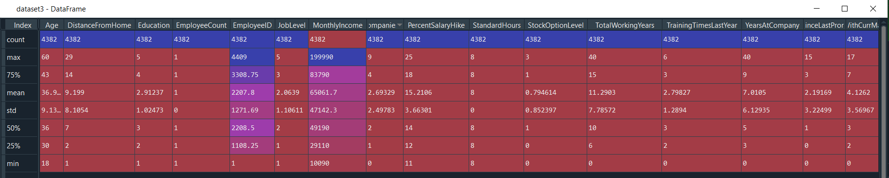

**Inference:**

* All the above variables in the dataset3 are positively skewed except for Education and EmployeeID which are negatively skewed.
* Age, Distance from home, Education and Percent Salary Hike are platyokurtic in nature whereas all other values are leptokurtic
* For age mean, median mode is nearly same and hence is normally distributed with an IQR (Q3 – Q1) of 13 years.

**Outliers:**

import matplotlib.pyplot as plt

plt.boxplot(dataset3.Age)

Out[30]:

{'whiskers': [<matplotlib.lines.Line2D at 0x2877e7b2a08>,

<matplotlib.lines.Line2D at 0x2877e7987c8>],

'caps': [<matplotlib.lines.Line2D at 0x2877efa8608>,

<matplotlib.lines.Line2D at 0x2877efaab08>],

'boxes': [<matplotlib.lines.Line2D at 0x2877e7b4d08>],

'medians': [<matplotlib.lines.Line2D at 0x2877f087748>],

'fliers': [<matplotlib.lines.Line2D at 0x2877efbdcc8>],

'means': []}

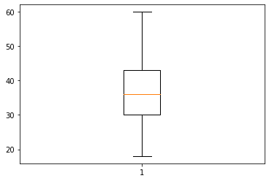

**As mean, median and mode are equal, Age is normally distributed without any outliers.**

plt.boxplot(dataset3.DistanceFromHome)

Out[31]:

{'whiskers': [<matplotlib.lines.Line2D at 0x2877e6f6788>,

<matplotlib.lines.Line2D at 0x2877e6f69c8>],

'caps': [<matplotlib.lines.Line2D at 0x2877e6f6448>,

<matplotlib.lines.Line2D at 0x2877e703388>],

'boxes': [<matplotlib.lines.Line2D at 0x2877e6e9648>],

'medians': [<matplotlib.lines.Line2D at 0x2877d7c7148>],

'fliers': [<matplotlib.lines.Line2D at 0x2877e6cbec8>],

'means': []}

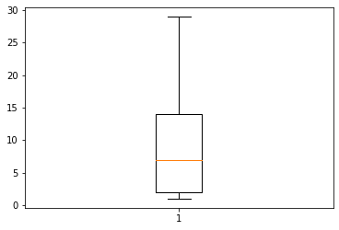

**DistanceFromHome is Right Skewed without any outliers.**

plt.boxplot(dataset3.Education)

Out[32]:

{'whiskers': [<matplotlib.lines.Line2D at 0x2877da59b48>,

<matplotlib.lines.Line2D at 0x2877da59448>],

'caps': [<matplotlib.lines.Line2D at 0x2877e6de988>,

<matplotlib.lines.Line2D at 0x2877ea83fc8>],

'boxes': [<matplotlib.lines.Line2D at 0x2877eda8588>],

'medians': [<matplotlib.lines.Line2D at 0x2877ea83b88>],

'fliers': [<matplotlib.lines.Line2D at 0x2877e6f0b88>],

'means': []}

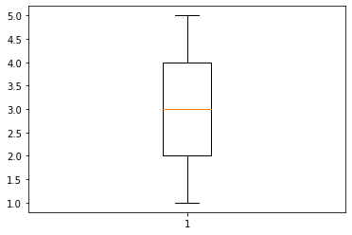

**Education is normally distributed without any outliers.**

plt.boxplot(dataset3.JobLevel)

Out[34]:

{'whiskers': [<matplotlib.lines.Line2D at 0x2877ec31cc8>,

<matplotlib.lines.Line2D at 0x2877ec31108>],

'caps': [<matplotlib.lines.Line2D at 0x2877edde3c8>,

<matplotlib.lines.Line2D at 0x2877edde748>],

'boxes': [<matplotlib.lines.Line2D at 0x2877ec315c8>],

'medians': [<matplotlib.lines.Line2D at 0x2877ee67b88>],

'fliers': [<matplotlib.lines.Line2D at 0x2877ee67648>],

'means': []}

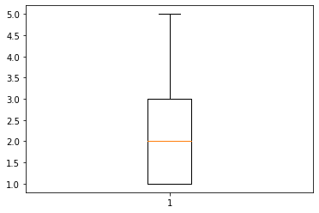

**JobLevel is normally distributed without any outliers.**

plt.boxplot(dataset3.MonthlyIncome)

Out[35]:

{'whiskers': [<matplotlib.lines.Line2D at 0x2877ef26548>,

<matplotlib.lines.Line2D at 0x2877eef1d08>],

'caps': [<matplotlib.lines.Line2D at 0x2877eef1888>,

<matplotlib.lines.Line2D at 0x2877eeb7c48>],

'boxes': [<matplotlib.lines.Line2D at 0x2877ef26208>],

'medians': [<matplotlib.lines.Line2D at 0x2877eeb7688>],

'fliers': [<matplotlib.lines.Line2D at 0x2877ee582c8>],

'means': []}

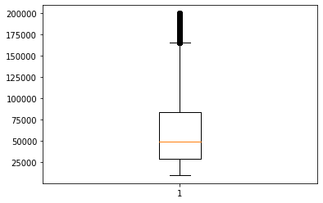

**MonthlyIncome is Right Skewed with several outliers. To remove outliers restrict the Monthly Income to 160000**

plt.boxplot(dataset3.NumCompaniesWorked)

Out[36]:

{'whiskers': [<matplotlib.lines.Line2D at 0x2877eec7348>,

<matplotlib.lines.Line2D at 0x2877ec4ee08>],

'caps': [<matplotlib.lines.Line2D at 0x2877ef60608>,

<matplotlib.lines.Line2D at 0x2877ef60bc8>],

'boxes': [<matplotlib.lines.Line2D at 0x2877ec4e888>],

'medians': [<matplotlib.lines.Line2D at 0x2877ec48548>],

'fliers': [<matplotlib.lines.Line2D at 0x2877ec48b48>],

'means': []}

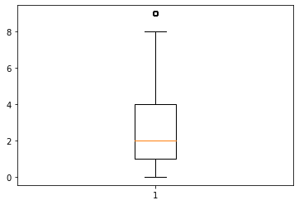

**NumCompaniesWorked is Right Skewed with few outliers.**

plt.boxplot(dataset3.PercentSalaryHike)

Out[37]:

{'whiskers': [<matplotlib.lines.Line2D at 0x2877ed683c8>,

<matplotlib.lines.Line2D at 0x2877ed686c8>],

'caps': [<matplotlib.lines.Line2D at 0x2877ed68cc8>,

<matplotlib.lines.Line2D at 0x2877ec36e88>],

'boxes': [<matplotlib.lines.Line2D at 0x2877ed5bac8>],

'medians': [<matplotlib.lines.Line2D at 0x2877ec360c8>],

'fliers': [<matplotlib.lines.Line2D at 0x2877ec28bc8>],

'means': []}

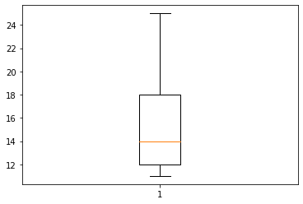

**PercentSalaryHike is Right Skewed without any outliers.**

plt.boxplot(dataset3.TotalWorkingYears)

Out[38]:

{'whiskers': [<matplotlib.lines.Line2D at 0x2877ecacf88>,

<matplotlib.lines.Line2D at 0x2877ecbd488>],

'caps': [<matplotlib.lines.Line2D at 0x2877ecbda88>,

<matplotlib.lines.Line2D at 0x2877ecc0bc8>],

'boxes': [<matplotlib.lines.Line2D at 0x2877ecaca48>],

'medians': [<matplotlib.lines.Line2D at 0x2877ecc0608>],

'fliers': [<matplotlib.lines.Line2D at 0x2877ecc63c8>],

'means': []}

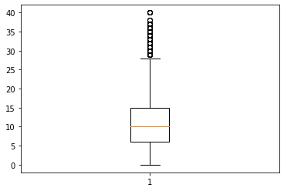

**TotalWorkingYears is normally distributed with several outliers.**

plt.boxplot(dataset3.YearsAtCompany)

Out[39]:

{'whiskers': [<matplotlib.lines.Line2D at 0x2877ed3a6c8>,

<matplotlib.lines.Line2D at 0x2877ed3a9c8>],

'caps': [<matplotlib.lines.Line2D at 0x2877ebdd288>,

<matplotlib.lines.Line2D at 0x2877ebdd948>],

'boxes': [<matplotlib.lines.Line2D at 0x2877ed33e48>],

'medians': [<matplotlib.lines.Line2D at 0x2877ebdddc8>],

'fliers': [<matplotlib.lines.Line2D at 0x2877ebc08c8>],

'means': []}

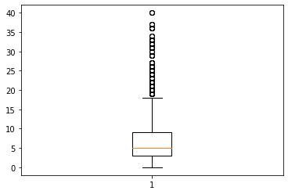

**YearsAtCompany is Right Skewed with several outliers.**

plt.boxplot(dataset3.YearsSinceLastPromotion)

Out[40]:

{'whiskers': [<matplotlib.lines.Line2D at 0x2877ebb6988>,

<matplotlib.lines.Line2D at 0x2877ebb6ac8>],

'caps': [<matplotlib.lines.Line2D at 0x2877eb9e448>,

<matplotlib.lines.Line2D at 0x2877eb9ea48>],

'boxes': [<matplotlib.lines.Line2D at 0x2877ebb6188>],

'medians': [<matplotlib.lines.Line2D at 0x2877eb7e648>],

'fliers': [<matplotlib.lines.Line2D at 0x2877eb7e208>],

'means': []}

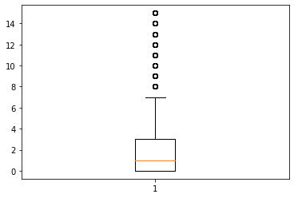

**YearsSinceLastPromotion is Right Skewed with several outliers.**

plt.boxplot(dataset3.YearsWithCurrManager)

Out[41]:

{'whiskers': [<matplotlib.lines.Line2D at 0x2877eb12208>,

<matplotlib.lines.Line2D at 0x2877eb12508>],

'caps': [<matplotlib.lines.Line2D at 0x2877eb12ac8>,

<matplotlib.lines.Line2D at 0x2877eb3a488>],

'boxes': [<matplotlib.lines.Line2D at 0x2877eb38a08>],

'medians': [<matplotlib.lines.Line2D at 0x2877eb3aa48>],

'fliers': [<matplotlib.lines.Line2D at 0x2877eb03408>],

'means': []}

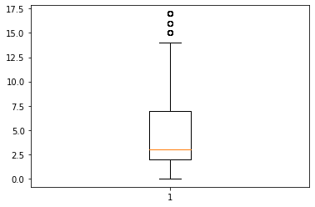

**YearsWithCurrManager is Right Skewed with few outliers.**